**The Library is for the Birds.**

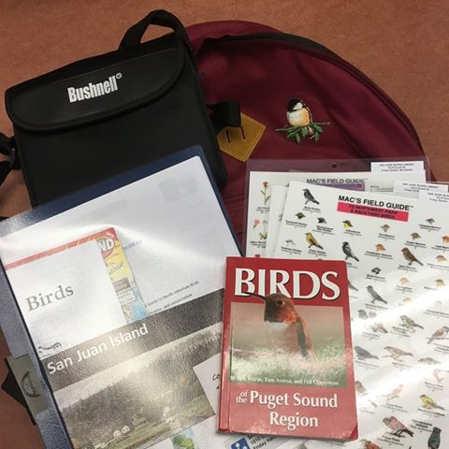

This summer the library is pleased to launch a new project made possible by the generous support of the Friends of the San Juan Island Library - Library Birdwatching Kits.

Have you ever been woken up at dawn (or earlier!) by loud, persistent birds? On a not-so-generous day you may wonder “when will it ever stop!!?” but on other days, you may find yourself asking “I wonder what that bird is?”

Well, now you can whip out a pair of binoculars and find the noisy culprits.

Great for beginners and experienced birders alike, the Library Birdwatching Kit comes conveniently in a handy backpack. Including a pair of Bushnells binoculars, a folder of handy information, and a “Birds of the Puget Sound Region” bird book, the kits are very convenient for hikes and general wandering.

There are maps and some hiking trails, a spotting sheet and laminated sheets of common birds, wildflowers and trees of the region.

Wanting to get started in birdwatching but not sure how? You can try a kit out to see what you like.

Available for a one week loan, come and check one out. One borrower even spotted whales!

Leslie Baker  
Assistant Director  
San Juan Island Library