**Book a librarian**

**Schedule an appointment with staff at a time that works for you. Get the specialized help you need to:**

* Learn to use a mouse and a computer
* Get started learning Office suite applications
* Create a new email account
* Write a resume

**Learn Online**

Use the library website to gain access to the Microsoft Imagine Academy where you can get hundreds of hours of free training in Microsoft products. Complete classes to get MS certification.

www.sjlib.org/db/msita

Visit the Goodwill Community Foundation Learnfree website for tutorials in dozens of digital technology skills from typing to email, Internet, Windows, Mac OS, Word, and Excel.

[www.gcflearnfree.org/technology](http://www.gcflearnfree.org/technology)

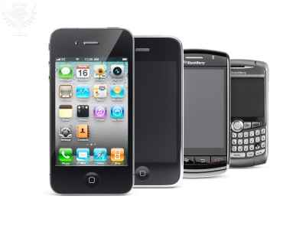

**Special workshops**

Look for occasional classes on these and other topics. Sign up to receive notices of Library programs via email so you won’t miss a class.

* **Manage digital photos**
* **Facebook for grownups**
* **Buying a new digital device**
* **Microsoft Word**
* **Microsoft Excel**

**Request a workshop**

The Library’s computer instruction program has largely developed out of patron suggestions and requests. Contact a librarian to ask for a class you need. If we can’t offer one, we will help you find online learning to meet your needs.

**Computer and Technology Instruction and Assistance** 

*Because new technology needs to be learned*

Windows desktops and laptops

Office software

Applications and Apps

Smartphones & Computer Tablets

Apple IOS &

Android Operating Systems



1010 Guard Street Friday Harbor, WA 98250

(360) 378-2798

www.sjlib.org

**Borrow and Read eBooks and eAudiobooks**

**Attend a tutorial session to get started using the Library’s electronic books. You will download and register the app, tour the website, and have access to our digital books for free.**

Wednesday, June 28, 3:00 – 4:30 pm

Wednesday, July 27, 3:00 – 4:30 pm

**Tech Tuesdays**

**Attend one or more drop in session for Tech help. Visit the Library meeting room any Tuesday morning from 10-noon with your technology questions. Bring your device, and Library volunteers will work with you one-on-one.**

**Free Workshops to** **Get Familiar with Your Digital Device**

**Register for these two-hour sessions at the Library information desk. Pick up a reminder slip so you’ll know what to bring to class.**

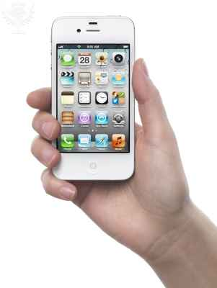You will need your device password, which may be an Apple ID (an email address and the password you set up for Apple to recognize).

Apple iPhone

Wednesday, June 8, 3 pm

Friday, August 5, 2 pm

Friday, October 7, 2 pm

Apple iPad tablet

Wednesday, June 22, 3 pm

Monday, August 8, 3 pm

Friday, October 21, 2 pm

Attention smartphone and tablet users:

You need to learn the operating system on your device, whether Android or IOS (Apple). You may sign up to take a class on the operating system you have, even if you don’t have the exact type of device (that is, phone users may take tablet classes and tablet users may take phone classes). You will still learn a lot.

Android Smartphone

Wednesday, June 29, 3 pm

Friday, September 2, 2 pm

Friday, November 4, 2 pm

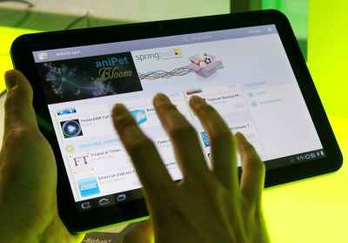

Android tablet

Wednesday, July 20, 3 pm

Friday, September 16, 2 pm

Friday, November 18, 2 pm